**Pl_SQL - Control Structures**

**Scenario 1: The bank wants to apply a discount to loan interest rates for customers above 60 years old.**

**Question: Write a PL/SQL block that loops through all customers, checks their age, and if they are above 60, apply a 1% discount to their current loan interest rates.**

**SQL Query:**

UPDATE Loans

SET InterestRate = InterestRate - 1

WHERE CustomerID IN (

SELECT CustomerID

FROM Customers

WHERE MONTHS_BETWEEN(SYSDATE, DOB)/12 > 60

);

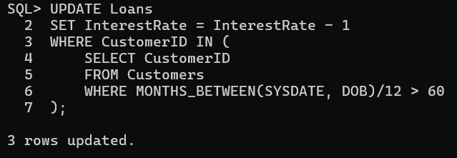

**Scenario 2: A customer can be promoted to VIP status based on their balance.**

**Question: Write a PL/SQL block that iterates through all customers and sets a flag IsVIP to TRUE for those with a balance over $10,000.**

**SQL Query:**

UPDATE Customers

SET IsVIP = 'T'

WHERE Balance > 10000;

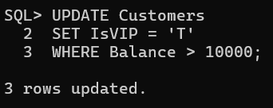

**Scenario 3: The bank wants to send reminders to customers whose loans are due within the next 30 days.**

**Question: Write a PL/SQL block that fetches all loans due in the next 30 days and prints a reminder message for each customer.**

**SQL Query:**

BEGIN

FOR rec IN (

SELECT l.LoanID, c.Name, l.EndDate

FROM Loans l

JOIN Customers c ON l.CustomerID = c.CustomerID

WHERE l.EndDate <= SYSDATE + 30

) LOOP

DBMS_OUTPUT.PUT_LINE('Reminder: Loan ID ' || rec.LoanID ||

' for ' || rec.Name || ' is due on ' || TO_CHAR(rec.EndDate, 'YYYY-MM-DD'));

END LOOP;

END;

/

